# Importing Packages for Logitech Steering Wheels

First, you will need to import latest **Logitech Gaming SDK** to your project. You can import it from **RCC Settings** (**Tools 🡪 BCG 🡪 RCC 🡪 Edit Settings**) or here;

https://assetstore.unity.com/packages/tools/integration/logitech-gaming-sdk-6630

Then you have to import “**RCC Logitech Gaming SDK Integration**” package to your Project. It can be found in **RealisticCarControllerV3** folder. If you import integration package before importing the SDK, you will have errors.

# How does it work?

**RCC_InputManager** will read inputs of the steering wheel with the new input system. **RCC_CarControllerV3** will be using these inputs in **Inputs()** method.

Inputs of the **G920 / G29** steering wheel have been configured with the new input system. Inputs can be edited by **RCC_InputActions** (**\Resources**). Before the new input system, inputs were processed by hardcoded scripts with communicating scripts of the Logitech’s SDK. Now, we don’t have to do it with that way. New input system will take care of this. We will still use Logitech SDK for the force feedback.

And lastly, be sure “**Steering Wheel Enabled**” is enabled in **RCC_Settings**. If you want to enable or disable it at runtime, you can do it by RCC_Settings.Instance.steeringWheelEnabled = true / false. There are some variables that we don’t want to use with the actual steering wheels such as steering sensitivity, steering limiter, steering assistance, etc… These variables will be overridden if it’s enabled.

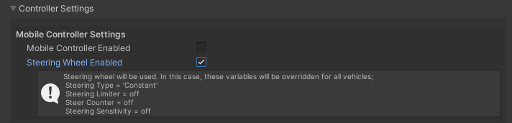

# What’s inside _RCCLogitechSteeringWheelManager?

It initializes connected steering wheel with SDK at start. Also listening to vehicle collision events for force feedback effects. Force of the feedback can be adjusted here.

# Notes & Advices

I’ve developed the integration with **Logitech G29/920 Steering Wheel**. Therefore, you may want to change some values in the script for different models. But it should work fine with all steering wheels if you can configure right inputs in **RCC_InputActions.**